Code Review Tool Analysis

The installation process is fairly easy, you just need to search in visual studio code’s extension menu the name of the tool, and click install. It appears first in the search results:

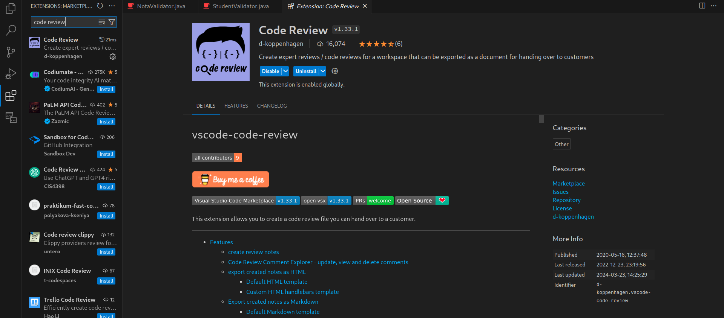

The review process is also straightforward: you select a code block, right click, select code review, and you get a window where you can add a title, category, description, and priority.

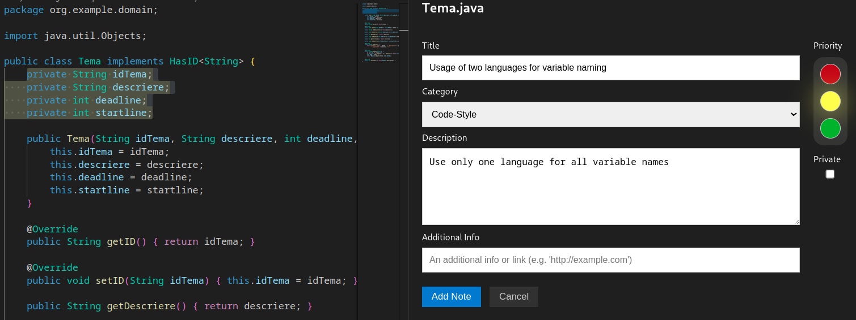  
After adding a note, it can be viewed in the code, or all the notes can be viewed by generating a report. The way to do this is by opening the VSCode Command Palette (ctrl+shift+p) and searching for Code Review. There we can see multiple export formats, such as html, csv, and so on.

To include the code snippet, not just the path to the code, we have to go the settings of the extension and tick the include code snippet checkbox. This is the generated html tempalte:

